# **LAB # 7**



# **Fall 2023 CSE402L Digital Signal Processing Lab**

Name: muneeza rehman

Registration No.: **21PWCSE2019**

Class Section: **C**

“On my honor, as student of University of Engineering and Technology, I have neither given nor received unauthorized assistance on this academic work.”

Submitted to:

# **Dr Yasir Saleem Afridi**

10 dec, 2023

Department of Computer Systems Engineering

University of Engineering and Technology, Peshawar

**Objectives:**

* To implement continuous-time signal using MATLAB
* To understand the characteristics of signals

**Source Code:**

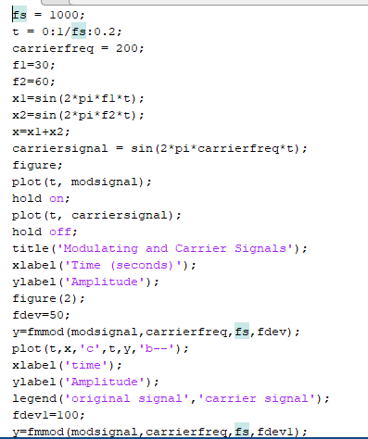

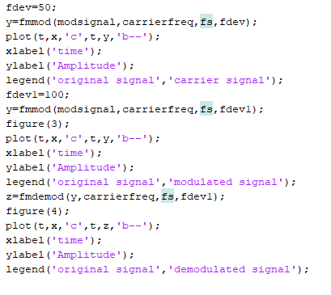

**Output:**

